Deals page

Can the “locations” be the same as is on the “Areas you would consider working”

Eg Northland, Auckland, Waikato etc…

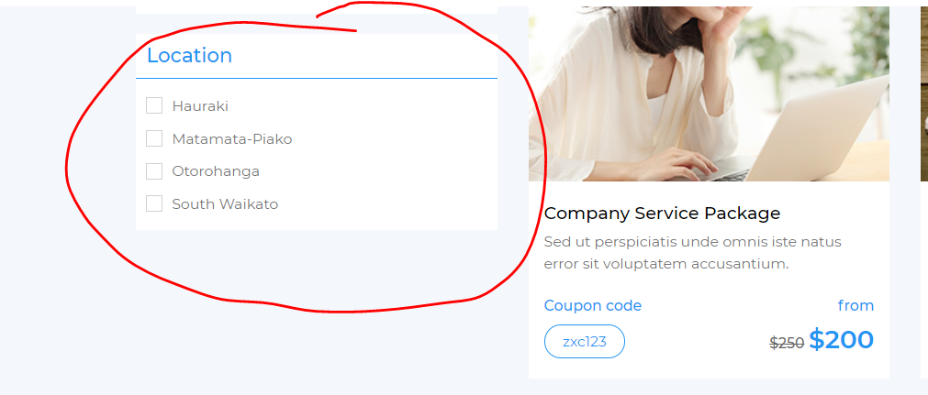

Can the “Categories” be the following

Accommodation & Parking

Automotive

Bargins.

Beauty, Massage & Spa

Camping & Outdoors

Clothing & Footwear

Motorhome, Caravan or Bus

Restaurants, Bars & cafes.

Services

Travel, Events & Activities

Other.

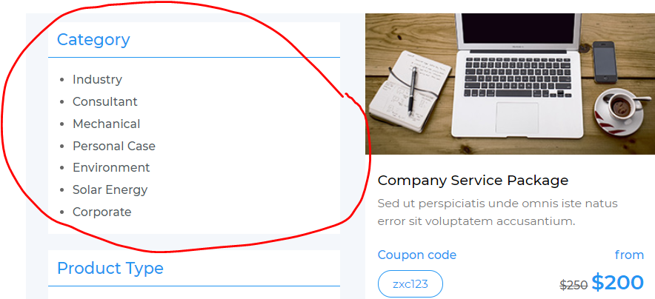

Can we remove this section but add a section that has a latest listing and or expiry date of deal instead.

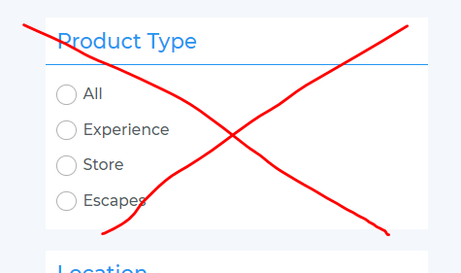

Can the “Search” be able to search any of the “heading and body” of any of the text

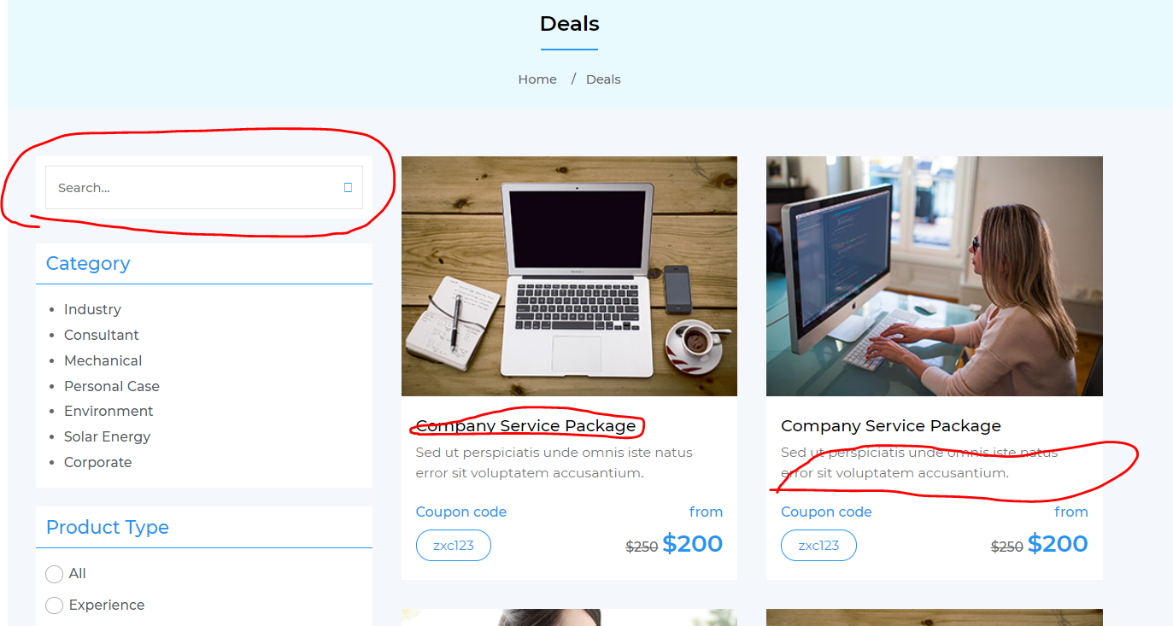

I like the size of the photos and layout.

Can the Heading be bigger Font and bolder please “**Company service package**” & Blue instead of Black coloured font.

Can the “From” be an optional field.

Can the “Coupon Code” be an optional field.

Can the place where you can add the crossed out amount “$250”Be Optional.

Are we also able to show a “expirey date” on the advert – Can this also be an optional field.

Because…. Some of it may be a straight advert, and some times they may add a deal.

If the above are optional fields then we can manage that in the back end.

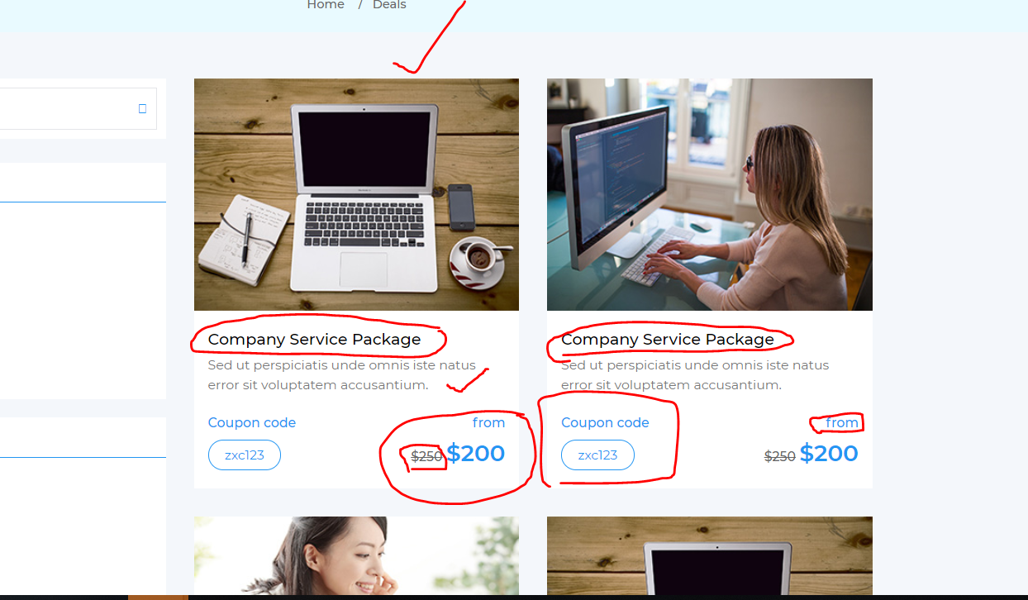

Back end management of deals page.

It is important that the back end we have a “start date” and and “end date” that the advert or deal will expire and that once it has gone past that date it will no longer show on the deals page.

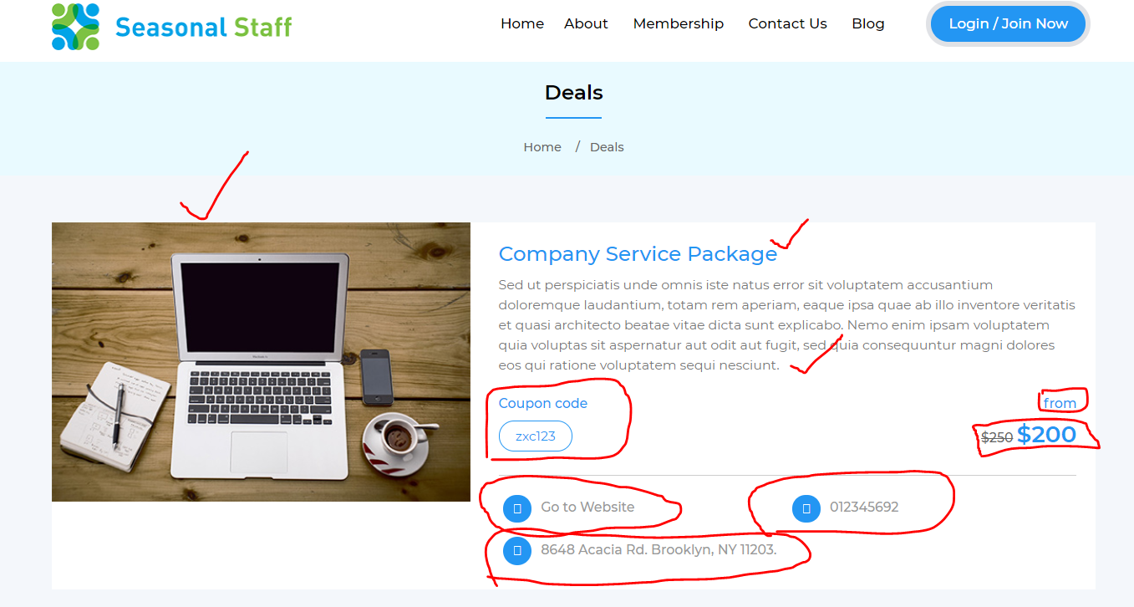

As previous notes make coupon codes “optional” – “From” optional, the “$250” cross out optional.

“Go to website” link to take them to an the external website in a separate window.

The phone number in a “Phone number” format

A place for “Address” see below format (optional)

A place for “opening hours format” (optional)

And a place to show the “Valid from” date and the “Expires” date (see below)

